Year 10
Unit 1- Introduction to IGCSE Global Perspectives



Student Workbook

Name: Isaac Chan

Introduction to the course

This 8-week introduction aims to introduce you to some of the key concepts and skills in the Cambridge IGCSE Global Perspectives course.

Global Perspectives is a course in which you will engage with a variety of global issues and seek to try and understand different perspectives, to develop your information literacy and critical thinking skills, as well as your ability to collaborate and lead in taking action on global issues.

Component 1: Written Examination – 35%  Component 2: Individual Research Report – 30%  Component 3: Team Project – 35% | 

Link to complete IGCSE Syllabus

Lesson 1- Introduction to Global Perspectives

What are the most serious issues for humanity?- ranking and justification

Food and Water Security
Climate Change

Health Pandemic

Deforestation
Crime
Religious Conflicts
Gender Inequality
Poverty
Racism

RELIGIOUS CONFLICTS | POVERTY | DEFORESTATION
CRIME | CLIMATE CHANGE | GENDER INEQUALITY
HEALTH PANDEMIC | RACISM | FOOD AND WATER SECURITY

Which issue is the most significant? And why?

Food and water security is the most significant issue because clean food and water are the basic requirements for human life - without them, no one can survive, let alone work, learn or improve their lives. It is also the issue that causes or worsens most of the others: a hungry population is more vulnerable to disease, more likely to turn to crime, and more likely to fight over scarce resources. Finally, it affects the most people - around 735 million people worldwide face hunger - making it both the most urgent and the most wide-reaching problem on the list.

Gallery Walk Activity

Look at the 8 images around the classroom that relate to one of the global perspectives topics. Which topic does it link to?

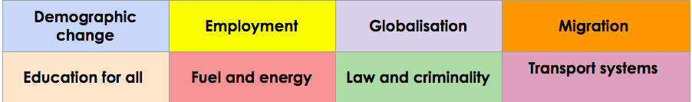

Photo | What does it show? Where is it? | Which of the 8 Exam topics does it link to?
1 | It shows a slightly fat guy on a bed reading a book in his bedroom | Law and Criminality
2 | A guy next to the tree | Employment
3 | A women with a piece of cloth on her head and says “I tell my stort because it is unique…” | Demographic change
4 | A lot of people protesing | Migration
5 | A photo of a lot of cars | Transport system
6 | 4 mans sitting on a chair chatting | Globalisation
7 | A photo of McDonald's has a clown next to it | Migration
8 | A white beard guy and black beard guy taking a photo of a truck | Fuel and Energy

Watch this video about the importance of the UN's Sustainable Development Goals for homework

Lesson 2 - Sustainable Development Goals ( SDGs)

The United Nations has outlined 17 goals - a blueprint or the “ultimate to do list” for the future of the planet.

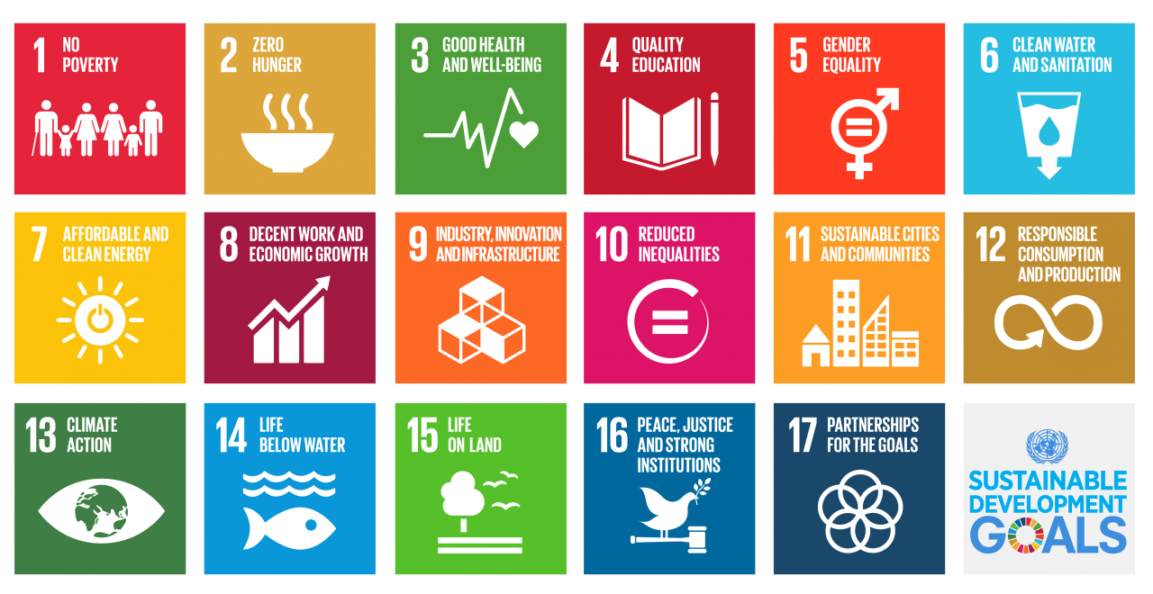

Watch this Video Introducing the UN - SDGs link

Consider one of the sustainable development goals - from this website

1. Identify an SDG that your group is interested in?
Life below water

2. Describe a solution that is being done at the local level (in a country) somewhere in the world?
In Hong Kong, local NGOs like Plastic Free Seas run regular beach clean-ups and school education programmes that stop plastic waste reaching the sea. Volunteers collect thousands of kilograms of rubbish from local beaches every year, and the education work teaches people to use less single-use plastic.
3. Explain how this scheme helps solve this issue?
This helps because it tackles pollution at two points: the clean-ups remove plastic that is already in the ocean before it can be eaten by turtles and fish, and the school programmes stop plastic entering the sea in the first place. Less plastic in the water means fewer animals trapped or killed, and cleaner beaches for people too.

4. What can different stakeholders do to take action on this, and what can they do?
Governments - ban single-use plastics and enforce fishing laws; Businesses - redesign packaging so it is recyclable and stop using plastic straws and bags; NGOs - run clean-ups, monitor pollution and pressure governments; Individuals - refuse plastic bags and straws, join clean-ups and choose sustainable seafood.

5. Which of the SDGs do you think is hardest to solve? Why?
1, because functions as the ultimate "downstream" consequence of all other societal failures

Stakeholders in solving the SDGs

Various groups can tackle issues at the local and global level.
Task: Match the following stakeholders in achieving the SDGs to their roles:( use colour codes)

stakeholders | What can they do to support the goals?
Community Groups | An organisation at the local level that encourages people to join together to tackle a problem in the community. Eg residents associations
World Bank | This organisation provides funding for governments who need to borrow money to help achieve goals.
United Nations | A global body who have an oversight of development for all countries and who created the SDGs
Individual citizens | As consumers and as part of civil society, these people are at the local level and can influence local decision makers
Non Governmental Organisations | Organisations providing funding and project management in locations around the world at the local, national and global eg Greenpeace
Businesses | Through making and selling goods and services they have the ability to influence the SDGs through the way they operate.
National governments | Attempt to implement and manage development policies within countries at the national level. Eg UK government.

What are the barriers to achieving global goals?

In your groups think about the factors that can prevent Global Goals from being achieved

What are the barriers or problems that can prevent progress in SDGs? Record some examples below from your group/class and post it as a flurry task. Share with the class.

Lack of funding - poor countries cannot afford waste treatment plants or patrol boats
Illegal and unregulated fishing - trawlers take fish faster than stocks can recover
Overfishing and bycatch - 33.1% of world fish stocks are overfished (FAO)
Plastic pollution - single-use plastics trap and kill marine animals
Rampant pollution - sewage, chemicals and microplastics flow into the sea
Climate change - warming and acidifying oceans destroy coral reefs
Weak laws and enforcement - countries struggle to police their own waters

Lesson 3- Investigating a Debatable Questions

You will undertake a research investigation in one of the following issues. These will be selected for each group using a random group picker.

You will work in a team of 3 or 4 to answer one of the following debatable questions working towards the common assessment task for this unit over the next few weeks. Teams will be allocated a question using a random name picker or by your teacher.

Debatable Research Questions examples

Change in Culture and Communities- This House believes that race and ethnicity, not merit, determine career success.
Employment- This House believes machines taking over jobs does more harm than good in poorer countries.
Globalisation - This House believes that globalisation is destroying unique local cultures.
Migration and urbanisation - This House believes that host nations should view mass migration as a threat, not an opportunity.
Education for all - This House believes that educating women is the single most important factor in a nation's development.
Climate change, energy and resources - This House believes that the environmental cost of transitioning to renewable energy is too high.
Law and criminality -This House believes that punishing criminals is more important than rehabilitating them.
Transport, travel and tourism - This House believes that we should never trust AI to drive our vehicles.

What do you already know about this issue?

As a team Create a Padlet/Bubblus or other mind map tool to show what your team know about this issue already- what are the causes and consequences of this issue- where is it a problem? what different perspectives exist on this issue?

Paste a screenshot of your PADLET/MIND MAP in the table below or copy and paste your mind map. Discuss your question with your class/teacher. How do you interpret this question and how you might answer it?

Research and resources

You can use some of these resources to get you started but you should also independently research your debatable question.

CHANGING CULTURES AND COMMUNITIES | EMPLOYMENT | GLOBALISATION | MIGRATION AND URBANISATION
Video  Article  Article  Article  Article | Article  Article  Article | Video  Article  Article  article | Video  Article  Article  Article
EDUCATION FOR ALL | CLIMATE CHANGE ENERGY AND RESOURCES | LAW AND CRIMINALITY | TRANSPORT, TRAVEL, AND TOURISM
Video  Article  Article  Article | Video  Article  Article  Article | Video  Video  Article  Article  Article | Video  Video  Article  Article  Article  Article

Lesson 4 - Causes and consequences
Using the resources above and your own research describe and explain what is happening in your issue at the local/ national and global level.
Local/National | - things that are caused or happen in a specific place/ ie a town or a city- social economic political environmental- air pollution in a city/country
Global | - things that are caused or happen at a global level- social economic political environmental- eg global warming

Local- Cause and consequence
What's happening:
In a garment-factory town in Bangladesh (or a city like Nairobi), factories are installing automated cutting and sewing machines. Hundreds of machinists lose their jobs in one factory at a time, while young people queue for fewer openings or move into app-based (Uber/boda boda) work controlled by algorithms.

cause | consequence
Machines are cheaper, faster and never get tired, so factory owners automate to cut costs and win orders | Local unemployment rises; families lose income; workers are pushed into informal/odd jobs with no security
Global buyers demand lower prices, forcing factories to automate to compete | Young people leave the town to find work, splitting up families (rural-urban migration)
Companies prefer machines because they do not go on strike or demand higher wages | Local workers without education or digital skills are left out of the new 'robot-friendly' jobs

National- cause and consequences
What's happening:
Across Kenya and Bangladesh, whole industries (garments, call centres, agriculture) are automating at once, while the government pushes new digital sectors - such as Kenya's M-Pesa and tech hubs - to replace the jobs lost.

cause | consequence
Falling robot prices worldwide make automation affordable even in lower-wage countries | Formal (registered, secure) jobs shrink; inequality grows between skilled and unskilled workers
Government policies attract foreign investment in modern factories | Tax revenue falls as factory jobs disappear, hurting schools and hospitals
Cheap labour is no longer enough of a selling point - China and others already use robots | The country's 'cheap labour' advantage erodes; it must climb the value chain or stay poor

Global -cause and consequence
What's happening:
Oxford Economics estimates up to 20 million manufacturing jobs worldwide will be lost to robots by 2030, with a 'disproportionate toll on lower-skilled workers and on poorer local economies' - robot-related job losses hit poorer regions almost twice as hard.

cause | consequence
The 'Fourth Industrial Revolution' - AI and robotics advancing faster than ever (Oxford Economics, 2019) | Global inequality widens: rich countries gain the productivity, poor countries lose the jobs
Global competition forces every country to automate or lose orders | The cheap-labour path that lifted China and East Asia out of poverty is closing for today's poor countries
COVID-19 pushed companies to automate even faster | Migration pressure grows as workers leave countries with no jobs

How do we measure the significance of an event or issue?



- IMPORTANT: People at the time thought it was important.
- PEOPLE: It affected a lot of people.
- EVENTS: It led to other important events.
- ATTITUDES: It changed people's attitudes or the way they lived.
- TIME: It affected people for a long time.
What are the most significant consequences and why?

Most significant cause and why? | Most significant consequence and why?
The falling cost of automation combined with global competition - because it forces poorer countries to automate whether they are ready or not, so it drives every other cause. | Losing the cheap-labour 'ladder' to development - because it was how billions of people escaped poverty (China, Vietnam, Bangladesh), and no country has found a replacement path yet.

Lesson 5 - Global perspectives survey- Values and perspectives

How do your views and values compare to other people in the world (UK)?  Complete the survey on this link and see how your views compare at the end of the survey. | 

What influences our perspectives?

Our perspectives on the world are influenced by a variety of factors. Many factors can make up our perspectives and influence our view of the world.
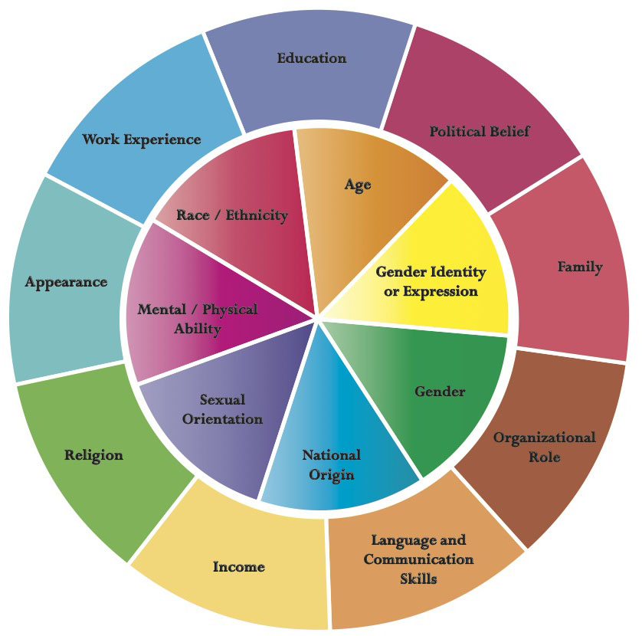

Give examples of how 3 of these factors could influence someone's opinions about your chosen issue ( debatable question):
Education / ability - A university graduate sees automation as an opportunity (new tech jobs, higher pay), while a primary-school-educated garment worker sees the same machines as the end of their livelihood. Education changes whether you fear or benefit from technology.
Age - A 16-year-old has grown up with phones and AI and expects to learn new skills easily, so they are more optimistic. A 55-year-old factory worker who cannot easily retrain faces losing their only skill, so they see automation as a threat.
Nationality / level of development - A Bangladeshi garment worker in a low-wage economy faces immediate job loss with no safety net, while a worker in wealthier Singapore has government retraining schemes and savings - so the same issue looks like a crisis to one and a change to the other.

Complete your own Identity wheel - Edit this diagram to outline your own identity wheel

RACE
ETHNICiTY
RELIGION
CLASS
EDUCATION/ ABILITY
NATIONALITY
LANGUAGE
AGE

How might a feature of your identity influence your perspectives on your chosen issue/ debatable question?
My education and age shape my view most. As a student in an international school with good access to technology, I am being educated to work with computers, not against them - so automation feels like an opportunity to me personally. I recognise this is a privileged position: if I had grown up in a poorer country with less schooling, the same machines would probably look like a threat instead. That is why I think we need to protect the people who are not as lucky as me.

Lesson 6 - Contrasting Perspectives

Identify and describe at least 2 contrasting views on this issue for your debatable question?

- Find a picture and /or names of specific people connected to this issue/experts/stakeholders
- Describe what their views/perspectives are on the issue?
- Quote what they have said about this issue
- Why might they think this? Who has the most convincing argument?

Who?  Photo | What’s their perspective? | Quote/Evidence | Why do they think this?
Bill Gates - co-founder of Microsoft and philanthropist (add a photo of him here) | Automation is replacing people faster than society is ready for, and the change hurts society unless governments act. He argues we should slow it down and use the money to help people retrain - for example through a 'robot tax'. | "You ought to tax the robot at a level that's slow enough that it's equal to the tax of a human doing that job." (Interview with Quartz, February 2017) | As a tech founder he knows exactly how powerful automation is; he believes its gains must be shared and displaced workers cushioned.
Jack Ma - founder of Alibaba, China's e-commerce giant (add a photo of him here) | AI and robotics will bring serious 'pain' and job losses in the coming decades - especially to unprepared countries - but the answer is NOT to stop technology; humans should focus on what machines cannot do, and governments must invest in education so people can adapt. | "In the next 30 years, the world will see much more pain than happiness." and "Machines should only do what humans cannot do." (public speeches, 2017) | He built his business in a developing country and knows poor countries must move up the value chain; he believes human creativity is the one thing machines cannot replace, so education is the only real protection.
Most convincing argument: Bill Gates - because his argument is evidence-based and offers a solution: the data (Oxford Economics: 20 million manufacturing jobs lost by 2030, poorer regions hit twice as hard) supports his concern, and the 'robot tax' gives governments something concrete to do. Jack Ma's argument is persuasive but is more about his personal belief that humans will adapt, which is a hope rather than a plan.

What makes an argument or a view more convincing?



Think about the following factors- discuss this as a group and class - - are there any examples of this in the research you have done so far?

Write 2 or 3 examples in the space below.

Language | Evidence | tone
Reasoning | Clarity of argument | structure/balance

1. Evidence - Oxford Economics' '20 million jobs by 2030' figure is much more convincing than a random post saying 'robots will end work', because it is based on real robotics data (International Federation of Robotics figures).
2. Balance - Gates admits new jobs will be created but explains the transition hurts the poorest most - a balanced argument is more convincing than a one-sided doomsday claim.
3. Authority - a study from the Oxford Martin School (Frey & Osborne) carries more weight than an anonymous social media opinion because of the institution's reputation and published methodology.

Lesson 7 - Information Literacy

Critical Thinking is a key skill in Global Perspectives. Being able to research and interpret different sources of information is a vital skill in Explorations. Below is some important vocabulary which is important to consider when researching and evaluating information. ( THIS IS REQUIRED FOR THE EXAM)

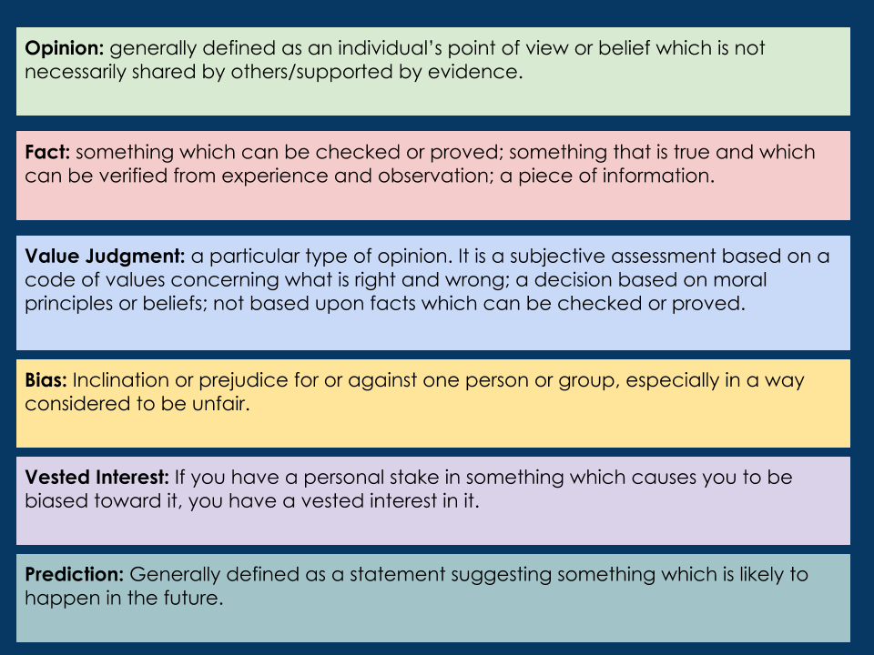

Can you find an example of 3 of these in your sources - use the Diigo chrome extension to annotate in the sources you have collected.- quote them in the table below.

 | evidence | Why this is | Source link
OPINION | "The rise of the robots will boost productivity and economic growth... But existing business models in many sectors will be seriously disrupted." | An opinion/prediction about future effects - it cannot be proven; it is the authors' judgement on what matters most. | https://www.oxfordeconomics.com/resource/how-robots-change-the-world/
FACT | "We estimate up to 20 million manufacturing jobs are set to be lost to robots by 2030." | A specific, checkable statistic with a published methodology - it can be tested against data. | https://www.oxfordeconomics.com/resource/how-robots-change-the-world/
PREDICTION | "About 47% of total US employment is at risk" of computerisation (Frey & Osborne, 2013). | A prediction - a forecast of future job risk based on modelling each occupation's probability of automation. | https://www.oxfordmartin.ox.ac.uk/publications/the-future-of-employment/

Lesson 8

In this session you will complete a CRAAP test for 2 contrasting sources of Information that you have used in your research so far.

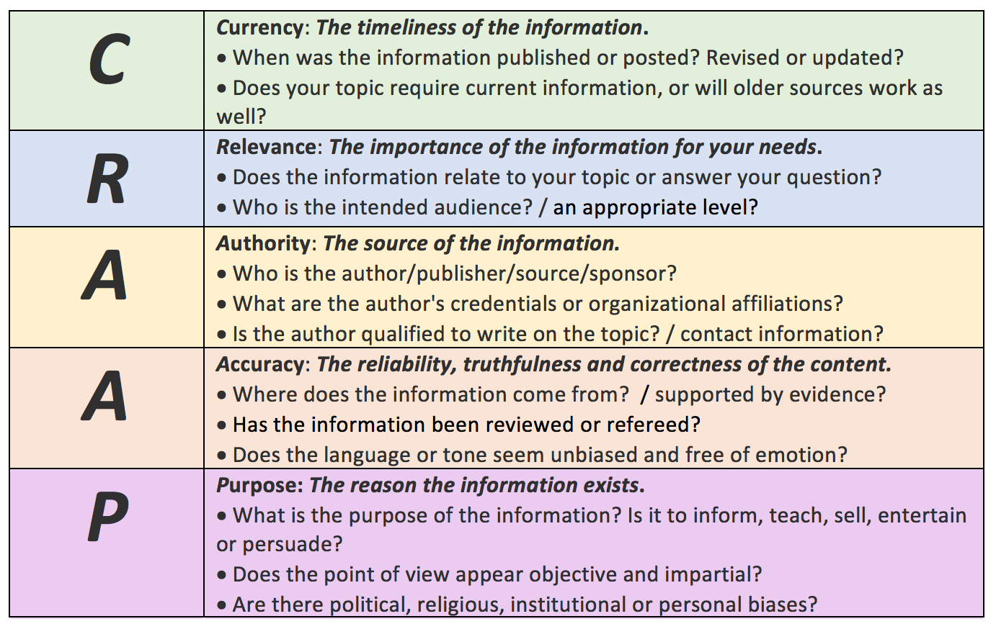

Source | CRAAP analysis
Source 1: Oxford Economics - 'How Robots Change the World' (2019), research/consultancy report  https://www.oxfordeconomics.com/resource/how-robots-change-the-world/ | Currency: 2019 - recent enough for a fast-moving topic (still the most-cited figure)  Relevance: directly about robots and manufacturing jobs, including poorer local economies - highly relevant  Authority: independent economic research consultancy whose reports are used by governments and the UN; methods published  Accuracy: based on International Federation of Robotics data; balanced (admits new jobs also appear)  Purpose: inform governments/businesses and influence policy - no adverts, but has clients, so broadly neutral  Verdict: reliable - use its data as evidence.
Source 2: Wikipedia - 'Technological unemployment' (encyclopaedia/reference page)  https://en.wikipedia.org/wiki/Technological_unemployment | Currency: continuously updated (2024-25)  Relevance: covers exactly this issue, including developing countries  Authority: medium - written by volunteer editors, but every claim must link to an original source (e.g. Keynes, Frey & Osborne)  Accuracy: high - it summarises verified studies rather than making new claims  Purpose: inform, neutral overview  Verdict: good for locating ideas and finding the original sources; don't cite Wikipedia itself in a final essay - follow its footnotes.

Lesson 9 - Courses of Action- Critical Thinking

 | Courses of action are potential strategies or things that can be done by different stakeholders to tackle problems or issues. - governments, business, communities etc  In Global perspectives for many issues in your exam the IRR essay or team project you will need to assess /evaluate different courses of action. These are things that have been already tried by different stakeholders to solve a problem.

 | Here is an example of 2 ways in which governments of countries approach the way that criminals are treated.  Watch the 2 videos about the ways in which countries like Norway and Singapore punish crimes.

 | Norway | Singapore
Describe the approach to the punishment of crime. | Rehabilitation - prisoners are treated as people to be fixed, not punished: open prisons like Halden, education and jobs inside, no bars on the windows. | Deterrence - harsh, fast punishment to scare people away from crime: caning, long sentences, and a mandatory death penalty for drug trafficking.
Strength | Recidivism (re-offending) is only about 20% - one of the lowest rates in the world; prisoners come out as useful citizens. | Crime stays very low; it is cheap to run; most citizens support it.
Weaknesses | Extremely expensive (over US$90,000 per prisoner per year); victims can feel justice was not served; it can look 'soft'. | Human-rights groups criticise caning and the death penalty (which cannot be reversed if a mistake is made).
Barrier/would this apply to other countries- if not why not? | It needs a wealthy state and high public trust - poor countries cannot afford it, and their people often demand harsher punishment. | It needs a strong-authority political culture; international pressure makes it hard for democratic countries to copy.

For your own debatable question/ issue- outline 2 potential courses of action that have been tried to solve this problem in other places.

Course of Action 1

What is the course of action- Describe it? | Giving every citizen (or every poor person) a regular, unconditional cash payment so they can survive and retrain when machines take their job.
Who has attempted this- government NGO, business, community etc... | The charity GiveDirectly (with researchers), funding a 12-year experiment in the poorest neighbourhoods of Nairobi, Kenya - over 20,000 people receive monthly cash (about US$50). Finland also ran a 2-year national trial (2017-18).
Where has this been tried? | Kenya (the longest-running experiment), Finland, Stockton (USA).
What are the strengths of this course in solving the problem | Puts money directly into the hands of the poorest - no bureaucracy; recipients use it to start small businesses or pay for training; known to boost wellbeing and entrepreneurship.
What are the weaknesses of this course in solving? | Very expensive in the long term; Kenya's trial is funded by foreign donors; some politicians oppose 'free money'; it protects income but does not create the jobs themselves.
Would this course of action be successful in all countries, if not why not? | No - it needs a country that can afford it and a system to pay people reliably; rich countries can, but the poorest countries cannot.
What might be a barrier to this being successful in another place? | Lack of government money, weak banking systems, and political opposition to giving people cash.

Course of Action 2

What is the course of action- Describe it? | Government programmes that train young people to earn online - freelancing, digital marketing, data entry, coding - through training hubs and online platforms.
Who has attempted this- government NGO, business, community | National governments, with UN agencies (ITU) and NGOs: Kenya's Ajira Digital programme and India's Skill India (PMKVY), which has trained millions.
Where has this been tried? | Kenya, India, Nigeria, Rwanda.
What are the strengths of this course in solving the problem | Directly answers the problem - it equips people for the jobs the machines cannot do; cheap per person; income can start within months; it grows the tech sector.
What are the weaknesses of this course in solving? | Only helps people who can learn digital skills - not today's 50-year-old factory workers; needs internet and electricity, which many villages lack; online freelance work can be low-paid and insecure.
Would this course of action be successful in all countries if not why not? | No - countries with poor internet, electricity and education levels cannot deliver it.
What might be a barrier to this being successful in another place? | No infrastructure, low literacy, and lack of devices (a phone or computer costs months of wages).

Personal perspective

In your teams you should consider what you think about your chosen issue. You should outline what you believe and why you think what you think- you might be able to refer back to key piece of evidence that have shaped your belief.

You should try to refer back to your original research question and attempt to conclude.

You can also conclude what you think should be done to solve the issue in the future
I believe that in poorer countries, machines taking over jobs does more harm than good - at least in the short term. Poorer countries built their development on cheap labour - garment factories and call centres - and automation removes that ladder before they have built any other way up. The evidence supports this: up to 20 million manufacturing jobs lost to robots by 2030, with poorer regions hit almost twice as hard. However, I do not think the answer is to ban technology - that is impossible anyway. Instead, my research question points to action: governments and international organisations should pair new technology with reskilling (like Kenya's Ajira Digital) and safety nets (like Kenya's UBI experiment) so the transition does not crush the poorest. The harm is real, but it is a policy problem - and policy can be fixed.

Lesson 10 and 11 - preparing for your presentation

Create a presentation with a selection of relevant images to support each section of your presentation:

- Preparing for your presentation
- Student Slideshow template
- Speech template

Prepare your presentation for next week- consider these resources to help you develop ideas for teams’ speech- each member of the team will deliver a different part of the presentation- this should be evenly divided between team members.

Good versus bad presentations video

Body Language in a presentation video

How to speak so that people want to listen video

Lesson 12 - Presentations

In todays lesson each group will report back to the class and will give the presentations for your chosen issue. Each member of the Team will be responsible for delivering an equal part of the presentation.

At the end of the lesson your class will give a score using the assessment criteria using a copy of a class google form that your teacher will share with you.

Give each of the teams a score out of 7 for both criteria.

Assessment criteria

 | Critical thinking | Communication | Positive Feedback comment
Team 1
Team 2
Team 3
Team 4
Team 5
Team 6
Team 7
Team 8

 | End of unit Reflection

Submit your final presentation and script to Toddle the summative assessment (SA) and link it to your Year 10 Student Booklet - Introduction to Global Perspectives 2025/2026

Paste these reflections about your learning in this unit to consider the following guiding questions:

1. What skills and knowledge have you learnt in this unit?
I have learned how to research a global issue properly - telling facts from opinions and predictions, testing sources with the CRAAP criteria, and finding causes and consequences at local, national and global levels. I also learned how identity and values shape perspectives, and how different stakeholders from governments to individuals can take action.
2. What have you enjoyed or done well in this unit?
I enjoyed researching automation in poorer countries - it is a topic I already cared about as a tech user. I think I did well at evaluating sources and finding concrete evidence (like the 20-million-jobs figure) to back up my argument.
3. What could you have improved on in this unit- critical thinking skills or communication?
Communication - I could have explained my points more clearly and used my evidence more in the presentation rather than just listing it. In critical thinking, I could have checked the bias of my sources earlier instead of assuming every source was trustworthy.
4. Can you use your slides or speech template for evidence of your growth in these areas ?
Yes - my early notes were just opinions, but my final slides structure the argument with evidence and courses of action, which shows I grew from opinion-based to evidence-based thinking.

News Presentation below in Term 3
Global and local issues- News analysis

What is going on in the world? As students of Global Perspectives we want you to take an interest in important issues and work towards understanding different perspectives on globally important issues..

 | During the first unit your group will be asked to report back on a NEWS REPORT - each team of 2-3 will report back on a news story-global or local. For between 1 to 2 minutes.  Your team will just do this once in this uni. Each member of the team should speak and you should include the following content:

- Some Visual- 2/ 3 photographs/headline
- What's the issue /problem?- description of the story/issue
- Who are the key stakeholders? (people affected/ involved in the issue)
- Why are you concerned? Why is this important to you/and us?
- Why should we care?

As a class try to choose different themed articles - your teacher may guide you on this

Here are a range of news links as well as physical newspapers. Link your groups news presentation slides in the space below



